Northeastern University
Data Mining in Engineering IE7275
CASE STUDY REPORT CRYTOCURRENCY ANALYTICS USING R

USE CASE STUDY REPORT
CRYTOCURRENCY ANALYTICS USING R

Student Name: Yarshil Shah & Amit Shivakumar

Executive Summary: Bitcoin and all the other cryptocurrencies in general are the craze now a days from an investment point of view. Apart from the high profits and overnight millionaire stories the currencies, are also infamous for frequent massive fluctuations in price . They were banned in Pakistan on April 7, 2018 among other countries which have already banned them if not on the verge of banning them like Russia,China,Taiwan,Bangladesh,Ecuador,Bolivia,Colombia,Thailand,Vietnam and Kyrgyzstan. This makes it a gamble to invest in ,the goal of this project was to predict if it ever was or is still viable to invest in these currencies.

Inferring from the existing data available which was collected from Kaggle.com and by using prediction methods we came to a conclusion that out of the 1514 currencies only five currencies “Bitcoin, Litecoin, Ripple, Ethereum, Bitcoin Cash" are safe to invest in relatively. Out of these currencies based on our findings the currency Ripple suffers from the least fluctuations and as a result is found to be the safest to invest in according to our findings.

II. Data Exploration and Visualization

The data had many Null and Not available values, which were found and removed to clean the data. The data was further processed by finding the many outliers through performing outlier tests and through plotting different graphs like Box plots and influence plots. The cleaned processed data was then used to create models and find the overall predictions.
Out of the overall 13 attributes which included “slug, symbol ,name, date , rank now, open, high, low, close ,volume, market, close_ratio, spread" only 7 which were relevant in predicting and obtaining the outcome variables namely close_ratio and spread were used to create the models. They are “name, open, high, low, close, close_ratio, spread".

Data mining techniques like logistic regression, Multiple linear regression, converting categorical variables to numerical variables among others were used to get the predicted values.

I. Background and Introduction
Aim: To examine the market trends and prices for various cryptocurrencies.

One of the most famous cryptocurrencies Bitcoin has been always touted as a stellar investment but it is also known for its notoriety with frequent and massive fluctuations.

Based on these historical trends predicting the worth of investment in these currencies, given the recent fluctuations and change in the legality of these currencies in various countries like Russia and China.

Given its notorious nature of frequent fluctuations in price and change in legality status in large economies, Bitcoin is valued at $10264 as of today. Clearly it is still desirable. We intend on using data mining techniques to see if the countries banning them influences its pricing and should one invest in these currencies anymore.

The possible solution would be to analyse the spread attribute in the data and decide on the viability of the investment based on the low spread values which would help us to decide on the safest cryptocurrency out of the 1514 different currencies in our data set.

II. Data Exploration and Visualization
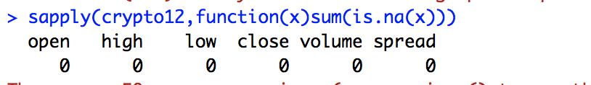
This shows that the data does not consist of any missing values.

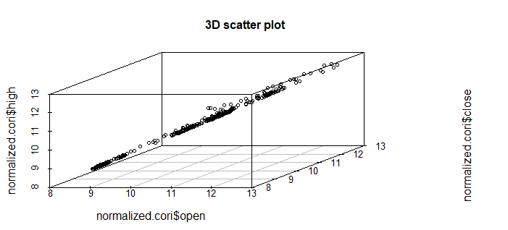

From the above 3D Scatter plot, we can see that the opening price, closing price and the daily high price are highly correlated

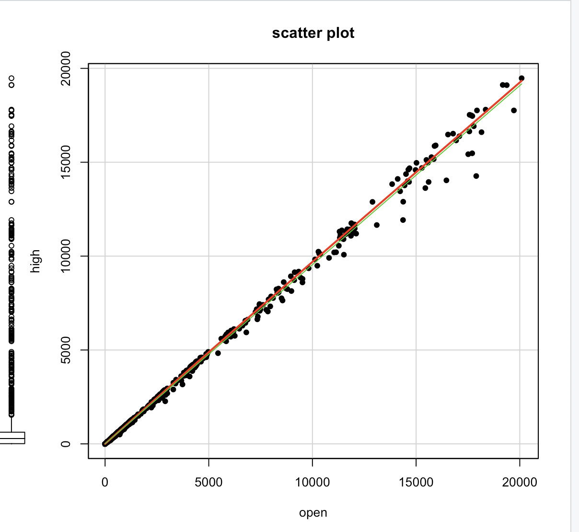

We can clearly see that the daily opening price and the high price of the day are highly correlated.
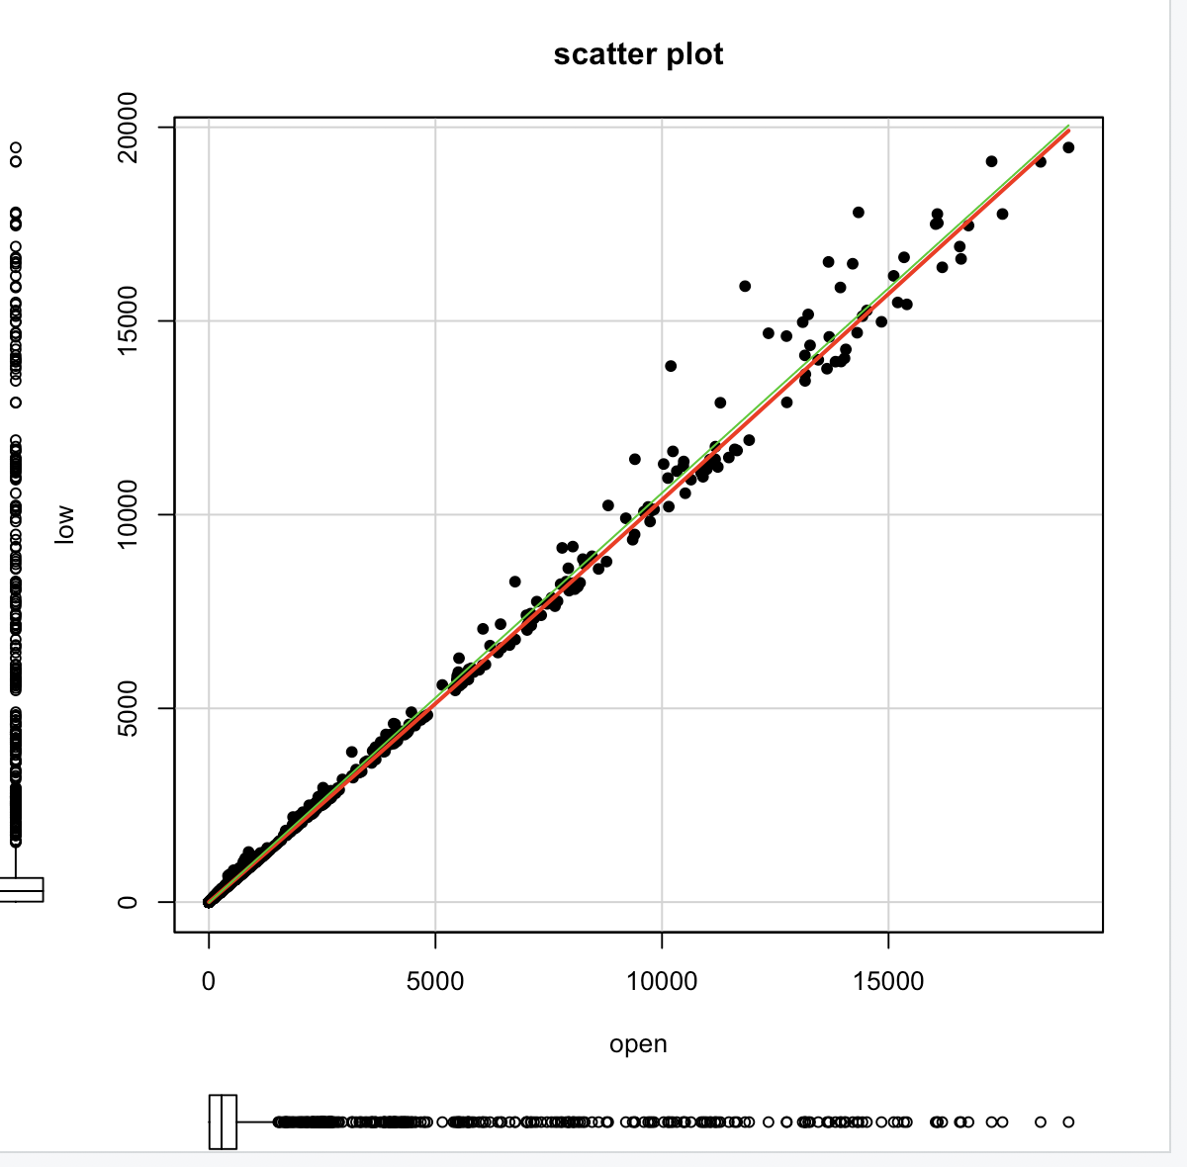

Similarly we observe that the daily opening price and the low price of the day are highly correlated.

We can see that the opening price of the day and closing price of the day are highly correlated.

Note -
Plotting a box plot for finding the spread of the data showed that there were many outliers. Therefore, we normalized the data to get box plots which had no outliers and thus also ridding the data set of those inherent outliers.

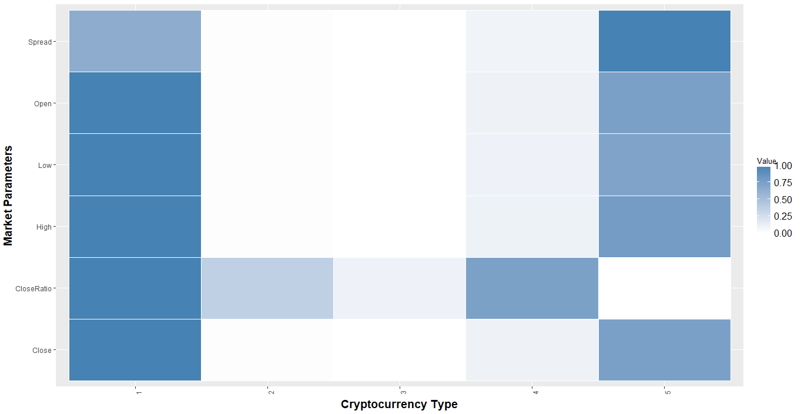

Heat Map
Key:
Bitcoin →1
Litecoin →2
Ripple →3
Ethereum →4
Bitcoin Cash →5

We generated the heat map which gives us a brief idea as to how different market parameters vary based on the cryptocurrencies. Here we observe the minimum spread is in the case of Ripple signifying it’s the safest option from the investment point of view.

Normalization and rescaling was done in order to scale the values in the range of 0 to 1 on the heat map.

III. Data Preparation and Preprocessing
Here the data and dimension reduction techniques like PCA and EFA couldn’t be used despite of the high correlations among the variables low, open, close and high as all the variables were important in the deriving the outcome variables “close ratio and spread”. So we found averages for the outcome variables and decided the five currencies with the least fluctuations to base out model on, this enabled us to reduce the data records drastically without affecting the overall quality of the prediction. The records were reduced from 702166 to 6328 hence reducing the time for operations and making the data more manageable to work with.
After cleaning the data and selecting the records and attributes to include in the models .

We decided to have the close ratio and the spread as the output variables. The input variables would be the Open price, Close Price, High Price and Low Price.

IV. Data Mining Techniques and Implementation
You may explore multiple data mining techniques as appropriate to your problem. Clearly state the problem in data mining context (e.g., classification, prediction, supervised/unsupervised learning, etc.). It is desirable to have a flowchart for the entire process from data cleaning/manipulation/variable selection and transformation to specific techniques/algorithms implemented in R.

We decided to perform multiple linear regression and logistic regression on the data set as this project is mainly a predictive problem which predicts the viability of investment in cryptocurrencies.

We converted the categorical variables into quantitative variables to obtain the correlations and scatter plot matrices.

We cleaned and processed the data set to get rid of the NULL values. Also post processing was carried out so that the cryptocurrencies with very high spread are eliminated from the data set. High spread signifies higher fluctuation in the market price which is undesirable.

Logistic regression was used to classify and predict which investment is the safest.

logit.reg.pred <- predict(logit.reg, valid.df[, -1], type = "response")

logistic.prediction<-data.frame(actual = valid.df$spread, predicted = logit.reg.pred)
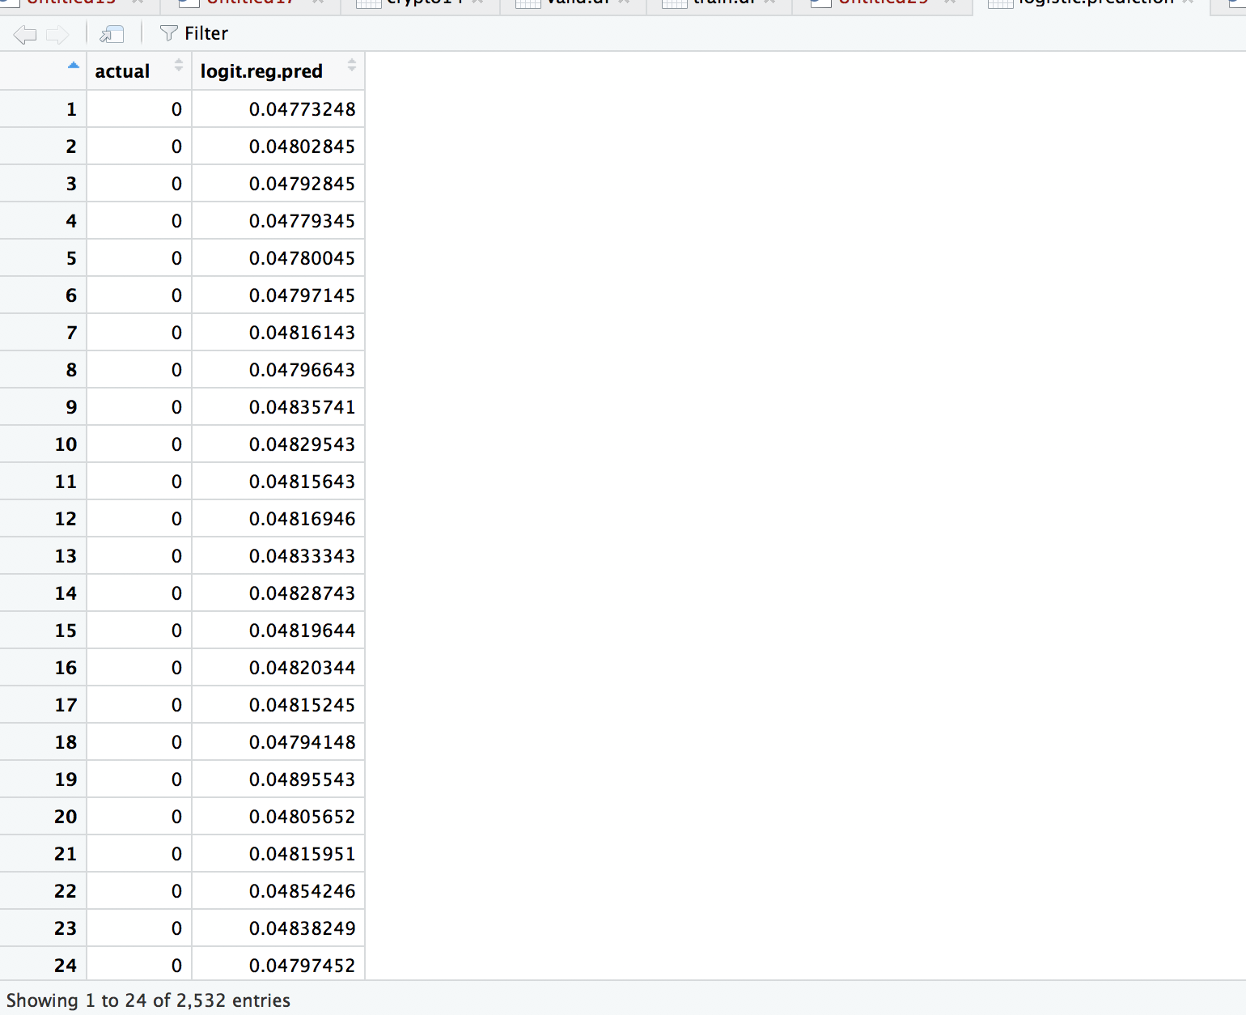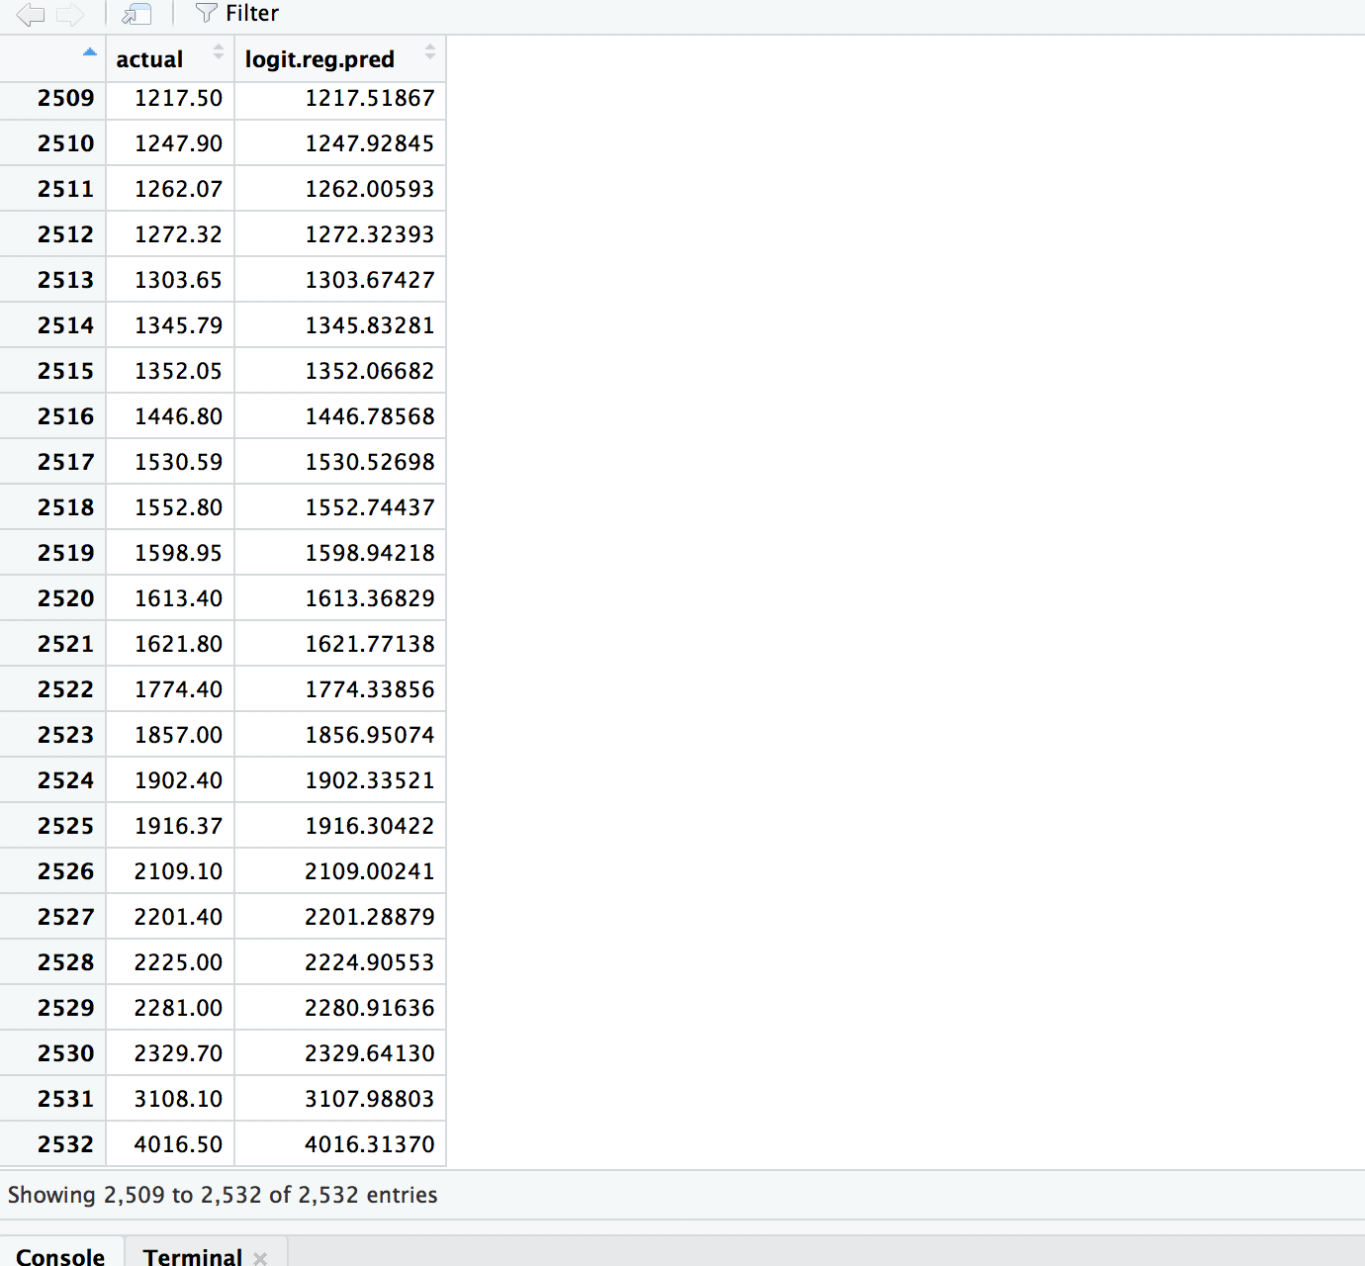
Close<-data.frame(actual = valid.df$close_ratio, predicted = logit.reg.pred)
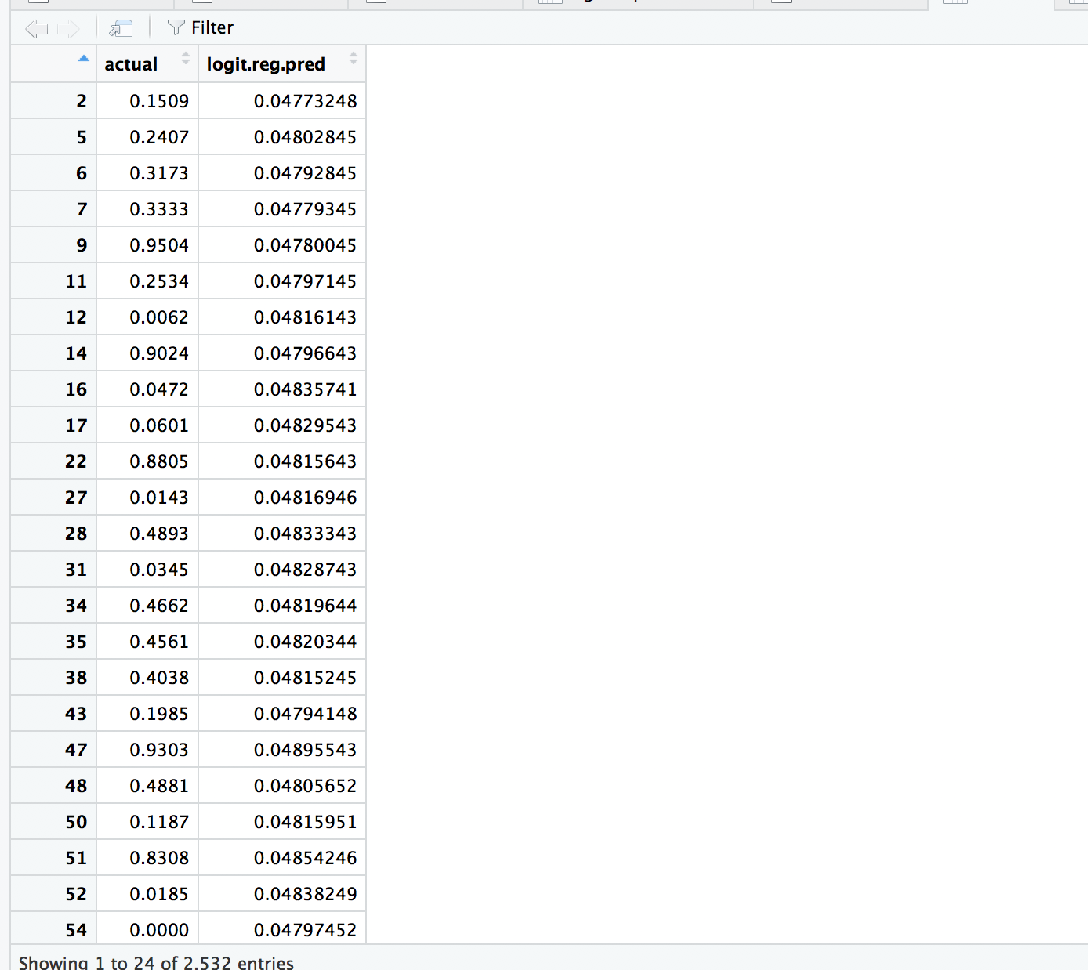
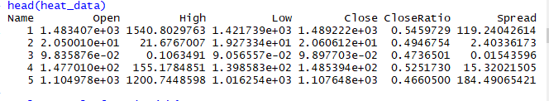
We observed that the average spread for type 3 cryptocurrency i.e. Ripple is the least which tells us that it is the safest option available for investment.

V. Performance Evaluation
As seen in the picture above the prediction fit1 predictions are really close to the actual values
fit1<-lm(spread~open+high+low+close+I(high+low+close+open^2),data=crypto14)

durbinWatsonTest(fit1)
lag Autocorrelation D-W Statistic p-value
1 0.002112493 1.995772 0.16
Alternative hypothesis: rho != 0

AIC(fit1,fit2)
df AIC
fit1 7 20743.54
fit2 5 8282.54

fit.full <-glm(formula = close_ratio~ open+high+low+close+spread, family = binomial(), data = crypto14)

fit2<-glm(formula = close_ratio~ open+high+low+close, family = binomial(), data = crypto14)

fit1<-glm(formula = spread~+open+high+low+close, family = binomial(), data = crypto14)

anova(fit2,fit.full,test = "F")
Analysis of Deviance Table

Model 1: close_ratio ~ open + high + low + close
Model 2: close_ratio ~ open + high + low + close + spread
Resid. Df Resid. Dev Df Deviance F Pr(>F)
1 6323 2732.3
2 6322 2732.3 1 0.0054401 0.0054 0.9412

ins_model <- lm(fit2,data=train.df)
ins_model
ins_predict <- predict(ins_model, valid.df)

ins_predict<-data.frame(ins_predict)

View(ins_predict)

ins_model <- lm(fit1,data=train.df)
ins_model
ins_predict <- predict(ins_model, valid.df)

ins_predict<-data.frame(ins_predict)

View(ins_predict)

predicted<-data.frame(ins_predict,valid.df$spread)
View(predicted)

Multiple linear Regression Predictions for spread
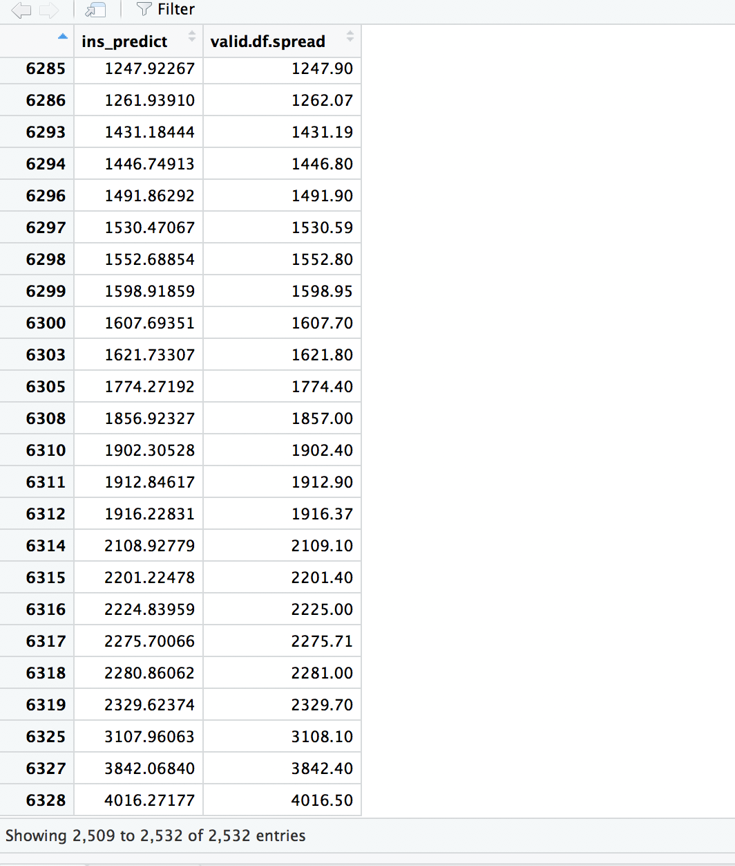
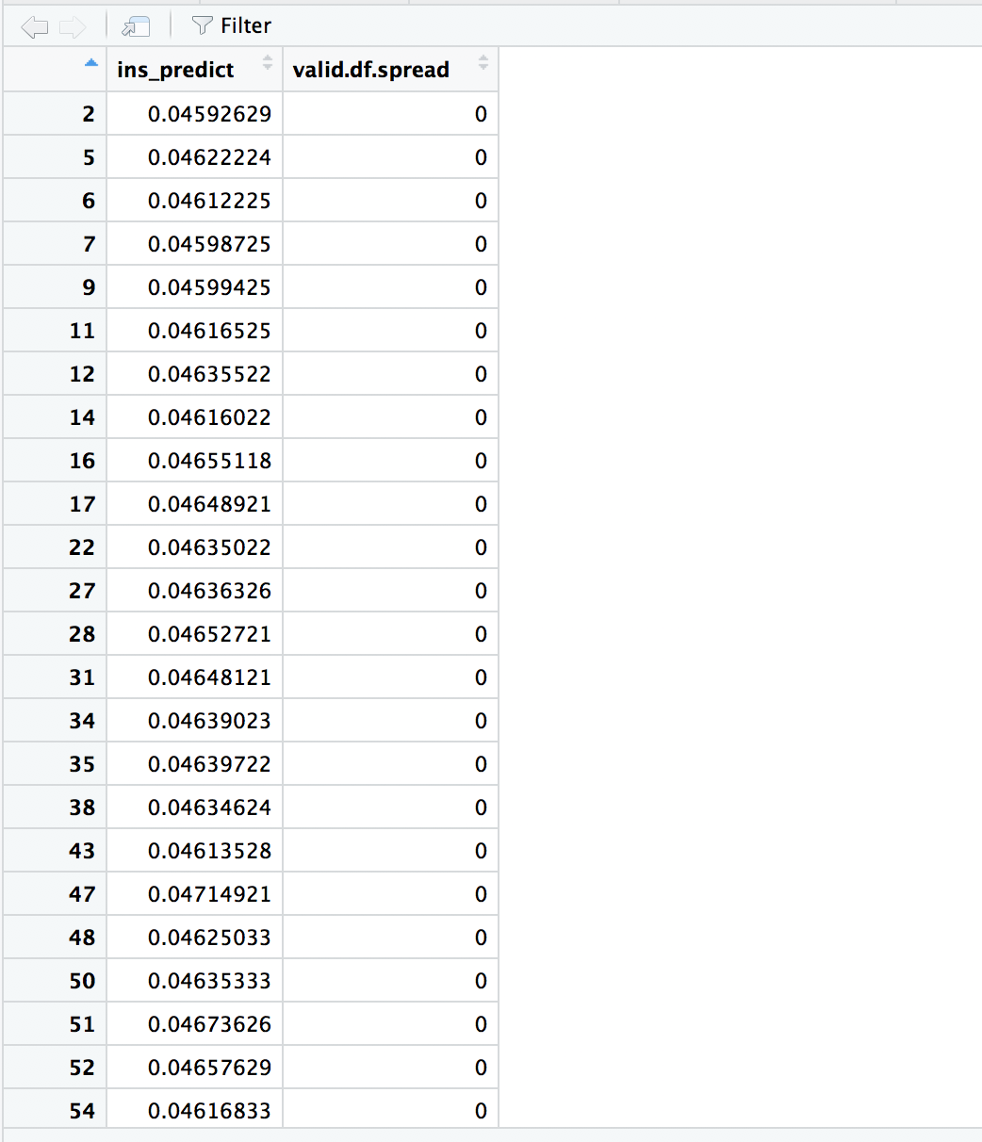

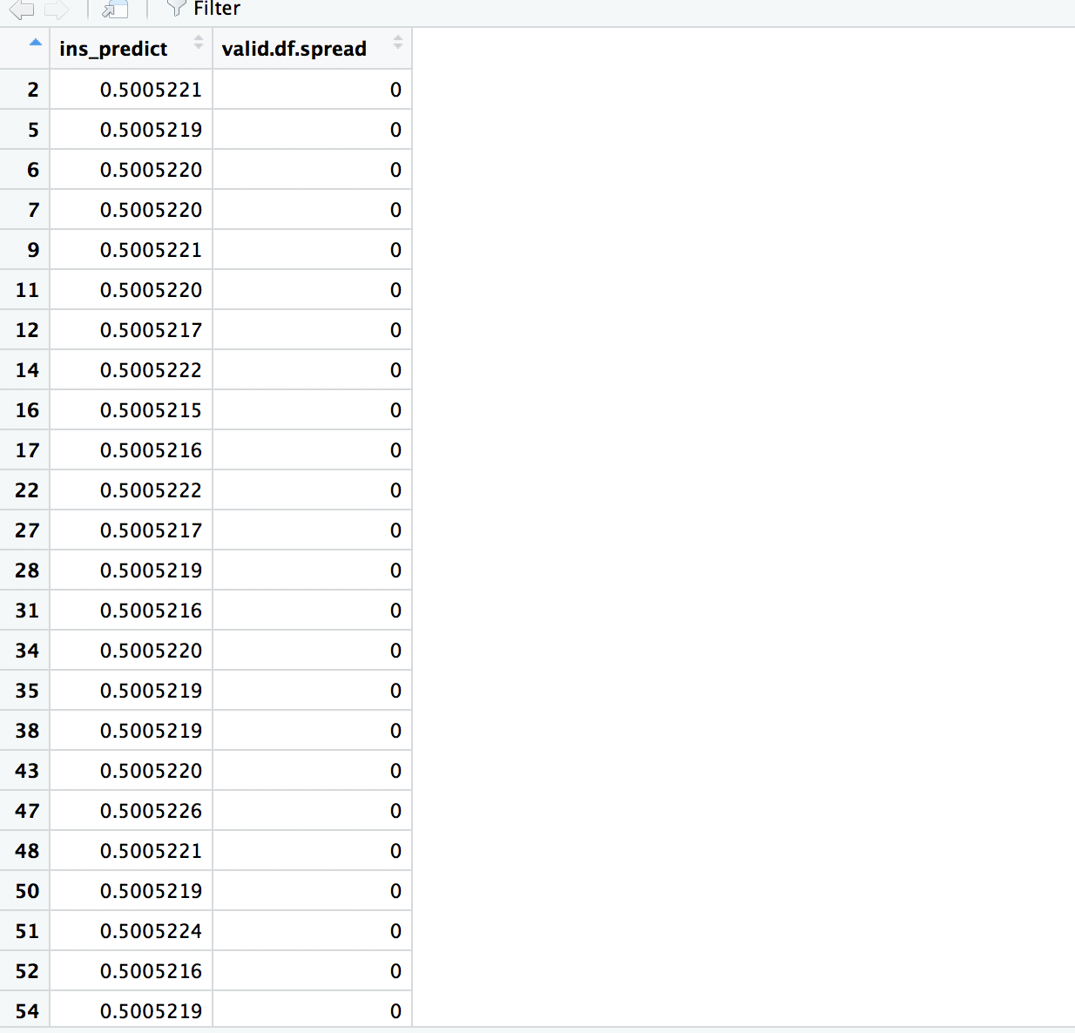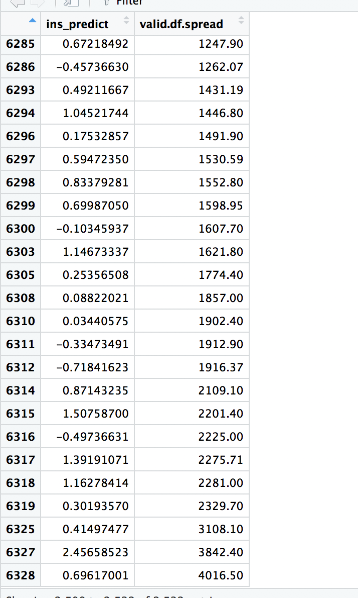

Clearly for multiple linear regression the second model returns a better AIC score and hence it is selected. The predictions have been done on both the initially decided outcome variables using both logistic as well as multiple linear regression.

VI. Discussion and Recommendation
Over all two approaches have been used for the predictions namely logistic and multiple linear regression to predict the outcome variables close ratio and spread initially.
But as the way the close ratio is derived from the predictor variables is too complicated the predictions for the linear models isn’t accurate. Besides the spread alone is self-sufficient in doing the job of predicting the stability of the given currencies on its own.
Hence, in conclusion outcome variables which are predicted from predictor variables using very complicated formulas or algorithms must be avoided when predicting using the linear regression or logistic regression techniques.

VII. Summary
In summary we can conclude that although not a sure shot profit guaranteed investment as it is thought to be, if one wants to make an investment Ripple which has an average spread value of 0.015 is a safe investment.

Appendix: R Code for use case study

crypto<-read.csv(file.choose())
names(crypto14)
crypto14<-read_excel(file.choose())#aic ccap bic,rsquare radjusted measure your model

crypto14$name <- factor(crypto14$name, levels = c("Bitcoin","Litecoin","Ripple","Ethereum","Bitcoin Cash"),
labels = c(1,2,3,4,5))
crypto16<-data.frame(crypto14)

crypto16
summary(crypto15$name)
summary(crypto14)
names(crypto14)
crypto14<-crypto14[1:6329,c(-1,-2,-4,-5,-10,-11)]
crypto14<-data.frame(crypto14)

summary(crypto14)

View(crypto14)

set.seed(2)
train.index <- sample(c(1:dim(crypto14)[1]), dim(crypto14)[1]*0.6)
train.df <- crypto14[train.index, ]
valid.df <- crypto14[-train.index, ]

cori<-crypto14[,c(-1)]
crypto12<-crypto12[,c(-1)]
str(crypto14)
cor(cori)
plot(cori)
plot(crypto14)

install.packages("sqldf")
library(sqldf)
names<-sqldf("Select count(distinct name) from crypto")
names

head(crypto14)
#create category variable

fit1<-lm(spread~open+high+low+close+I(high+low+close+open^2),data=crypto14)
anova(fit1,fit.full,test="chi")
par(mfrow=c(2,2))
plot(fit1)

summary(fit1)

#for the qq plot some of the normality constraints have been violated as the points are not on the 45 degree line
#Residual vs fitted shows a curved relationship hence a cleary quadratic term is required
#Homoscedicity has been met as all the points in the residual vs leverage graph are a random collection around a linear line

library(class)
crypto.knn.pred<- knn(train.df, test=valid.df, cl=train.df, k=5)
crypto.knn.pred<-data.frame(crypto.knn.pred)
crypto.valid<-valid.df
cor(crypto.valid$close_ratio, as.numeric(crypto.knn.pred))#0.8034

residplot <-function(fit1, nbreaks=10) {
z <- rstudent(fit1)
hist(z, breaks =nbreaks, freq = FALSE,
xlab = "Studentized Residuals ",main="Distribution of errors")
rug(jitter(z),col="brown")
curve(dnorm(x,mean=mean(z), sd=sd(z)),
add=TRUE, col="blue", lwd=2)
lines(density(z)$x, density(z)$y,col="red", lwd=2, lty=2)
legend("topright",legend = c("Normal Curve","Kernel Density curve"),lty=1:2,col=c("blue","red"), cex=.7)}

residplot(fit1)
#multiple linear regression ,classifocation ,logistic regression then decision tree
AIC(fit1,fit2)

library("car")

ins_model <- lm(,data=train.df)
ins_model
ins_predict <- predict(ins_model, valid.df)

ins_predict<-data.frame(ins_predict)

View(ins_predict)

#optimal predictor variables

logit.reg.pred <- predict(fit1, valid.df, type = "response")
logit.reg.pred<-data.frame(logit.reg.pred)
View(logit.reg.pred)

# first 5 actual and predicted records
close<-data.frame(actual = valid.df$close_ratio, predicted = logit.reg.pred)

data.frame(actual = valid.df$close_ratio,poisson(link = log))

summary(logit.reg.pred)

predict<-ins_predict[!is.na(ins_predict)]
predict

scatterplot(open~high,data=crypto14,spread=FALSE,lty.smooth=2,pch=19,main="scatter plot",xlab="open",ylab="high")

scatterplot(open~low,data=crypto14,spread=FALSE,lty.smooth=2,pch=19,main="scatter plot",xlab="open",ylab="low")

scatterplot(open~close,data=crypto14,spread=FALSE,lty.smooth=2,pch=19,main="scatter plot",xlab="open",ylab="close")

scatterplot(open~volume,data=crypto14,spread=FALSE,lty.smooth=2,pch=19,main="scatter plot",xlab="open",ylab="volume")

scatterplot(open~spread,data=crypto14,spread=FALSE,lty.smooth=2,pch=19,main="scatter plot",xlab="open",ylab="spread")

library("car")

library("residplot")
residplot(fit1)

durbinWatsonTest(fit1)

scatterplotMatrix(crypto14,spread = FALSE,lty.smooth=2,main="Scatter Matrix")

install.packages("gvlma")
library(gvlma)

rowSums(is.na(crypto16))

#counting 0's
gvlma1<-sapply(crypto14,function(x)sum(is.na(x)))

summary(gvlma1)
#logistic regression
logit.reg <- glm(name ~ ., data = train.df, family = "binomial")

options(scipen=999)

summary(logit.reg)

logit.reg.pred <- predict(logit.reg, valid.df[, -1], type = "response")

logistic.prediction<-data.frame(actual = valid.df$spread, predicted = logit.reg.pred)

logit.reg <- glm(name ~ ., data = train.df, family = "binomial")
logit.reg<-data.frame(logit.reg)
View(logis)

options(scipen=999)

summary(logit.reg)

logit.reg.pred <- predict(logit.reg, valid.df[, -1], type = "response")

logistic.prediction<-data.frame(actual = valid.df$spread, predicted = logit.reg.pred)

View(
logistic.prediction)

logit.reg <- glm(crypto14$name ~ ., data = train.df, family = "binomial")

#

fit.full <-glm(formula = close_ratio~ open+high+low+close+spread, family = binomial(), data = crypto14)

fit2<-glm(formula = close_ratio~ open+high+low+close, family = binomial(), data = crypto14)

summary(fit2)

anova(fit2,fit.full,test = "F")

testdata$prob <- predict(fit2, newdata=testdata, type="response")

testdata

testdata <- data.frame(name=c(1, 2, 3, 4, 5), open=mean(crypto14$open),high=mean(crypto14$high),
low=mean(crypto14$low),close=mean(crypto14$close),close_ratio=mean(crypto14$close_ratio))

predicti<-predict(fit2,interval="confidence")
predicti<-data.frame(predicti)
View(predicti)

View(fit2)

View(
logistic.prediction)

logit.reg <- glm(crypto14$name ~ ., data = train.df, family = "binomial")

#

fit.full <-glm(formula = close_ratio~ open+high+low+close+spread, family = binomial(), data = crypto14)

fit2<-glm(formula = spread~+open+high+low+close, family = binomial(), data = crypto14)

summary(fit2)

library(car)

outlierTest(crypto14$spread)
boxplot(crypto14$spread)

crypto15<-sort(crypto14$spread,decreasing = FALSE)

View(crypto14)
View(crypto15) #4755 its 10
asc <- crypto14[order(crypto14$spread),]

proj.dat<-data.frame(Bitcoin, Ethereum,Ripple, BitcoinCash, Litecoin)
proj<-data.frame(proj,proj.dat)
crypto14<-data.frame(crypto14)
View(crypto14)
summary(crypto14)

View(crypto14)

set.seed(2)
train.index <- sample(c(1:dim(crypto14)[1]), dim(crypto14)[1]*0.6)
train.df <- crypto14[train.index, ]
valid.df <- crypto14[-train.index, ]

cori<-crypto14[,c(-1)]
crypto12<-crypto12[,c(-1)]
str(crypto14)
cor(crypto14)
cor(cori)
plot(cori)
plot(crypto14)

#create category variable

summary(fit1)

#for the qq plot some of the normality constraints have been violated as the points are not on the 45 degree line
#Residual vs fitted shows a curved relationship hence a cleary quadratic term is required
#Homoscedicity has been met as all the points in the residual vs leverage graph are a random collection around a linear line

library(class)
crypto.knn.pred<- knn(train.df, test=valid.df, cl=train.df, k=5)
crypto.knn.pred<-data.frame(crypto.knn.pred)
crypto.valid<-valid.df
cor(crypto.valid$close_ratio, as.numeric(crypto.knn.pred))#0.8034

residplot(fit1)
#multiple linear regression ,classifocation ,logistic regression then decision tree

library("car")

ins_model <- lm(fit2,data=train.df)
ins_model
ins_predict <- predict(ins_model, valid.df)

ins_predict<-data.frame(ins_predict)

View(ins_predict)

predicted<-data.frame(ins_predict,valid.df$spread)
View(predicted)

#optimal predictor variables

logit.reg.pred <- predict(fit1, valid.df, type = "response")
logit.reg.pred<-data.frame(logit.reg.pred)
View(logit.reg.pred)

# first 5 actual and predicted records

Close<-data.frame(actual = valid.df$close_ratio, predicted = logit.reg.pred)
View(Close)

data.frame(actual = valid.df$close_ratio,poisson(link = log))

summary(logit.reg.pred)

predict<-ins_predict[!is.na(ins_predict)]
predict

scatterplot(open~high,data=crypto14,spread=FALSE,lty.smooth=2,pch=19,main="scatter plot",xlab="open",ylab="high")

scatterplot(open~low,data=crypto14,spread=FALSE,lty.smooth=2,pch=19,main="scatter plot",xlab="open",ylab="low")

scatterplot(open~close,data=crypto14,spread=FALSE,lty.smooth=2,pch=19,main="scatter plot",xlab="open",ylab="close")

scatterplot(open~volume,data=crypto14,spread=FALSE,lty.smooth=2,pch=19,main="scatter plot",xlab="open",ylab="volume")

scatterplot(open~spread,data=crypto14,spread=FALSE,lty.smooth=2,pch=19,main="scatter plot",xlab="open",ylab="spread")

residplot(fit1)

## Function - To Install & Load Packages ##
package_install_load <- function(package) {

if (!require(package, character.only = TRUE)) {
install.packages(package, dep = TRUE)
if (!require(package, character.only = TRUE)) {
stop("Package not found")
}
}
else{
print(paste("Package", package, "loaded"))
}
}

### Load Required Packages ###
packages <- c("plyr", "dplyr", "readr", "tidyr","ggplot2","sqldf", "scales",
"gains","rpart", "rpart.plot","ellipse","corrplot","RColorBrewer","jsonlite")
invisible(lapply(packages, package_install_load))

crypto <- crypto14

heat_data <- sqldf("SELECT name as Name, avg(open) as Open, avg(high) as High,
avg(low) as Low, avg(close) as Close, avg(close_ratio) as CloseRatio,
avg(spread) as Spread
FROM crypto
GROUP BY name ORDER BY name")

names(heat_data)
head(heat_data)

scale_rescale=function(x){
return(rescale(scale(x)))
}

heat_data <-cbind(heat_data$Name,as.data.frame(lapply(heat_data[c(2,3,4,5,6,7)], scale_rescale)))

names(heat_data)[1] <- "Name"

head(heat_data)

heat_data <- heat_data %>%
gather(Parameter, Value, Open:Spread)

head(heat_data)

ggplot(heat_data, aes(Name, Parameter )) +
geom_tile(aes(fill = Value), color = "white") +
scale_fill_gradient(low = "white", high = "steelblue") +
#scale_colour_gradientn(colours = color_palette) +
ylab("Market Parameters") +
xlab("Cryptocurrency Type") +
theme(legend.title = element_text(size = 10),
legend.text = element_text(size = 12),
plot.title = element_text(size=16),
axis.title=element_text(size=14,face="bold"),
axis.text.x = element_text(angle = 90, hjust = 1))

Thanking you

Yarshil and Amit

